**Case study | Azure Data Bricks**

**Divya Sree Murali**

**Create a workspace and add three notebooks for each of ETL process**

**Notebook 1--🡪Extract---[Reading raw Data]**

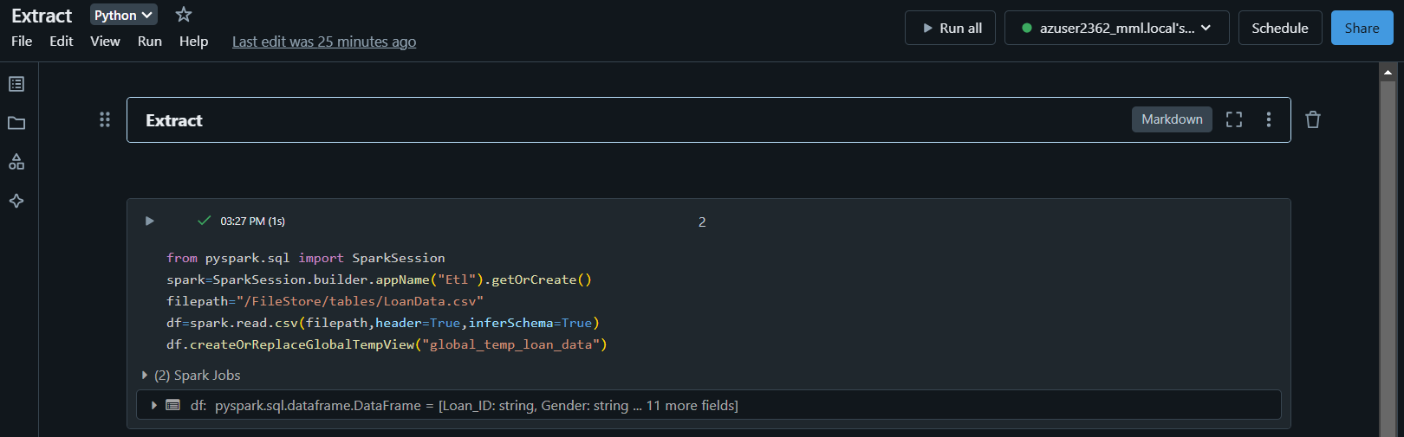

**Notebook 2🡪Transform---[Apply suitable transformations on raw data**

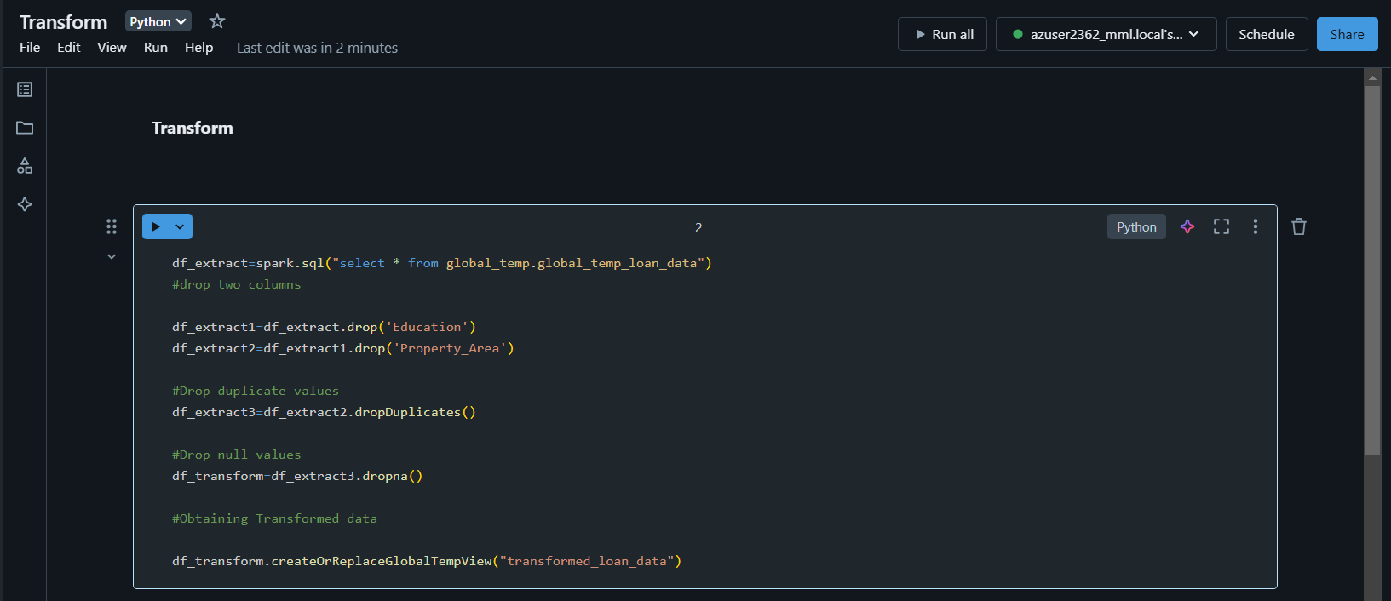

**Notebook3--🡪Load----[Loading the transformed data and saving as table]**

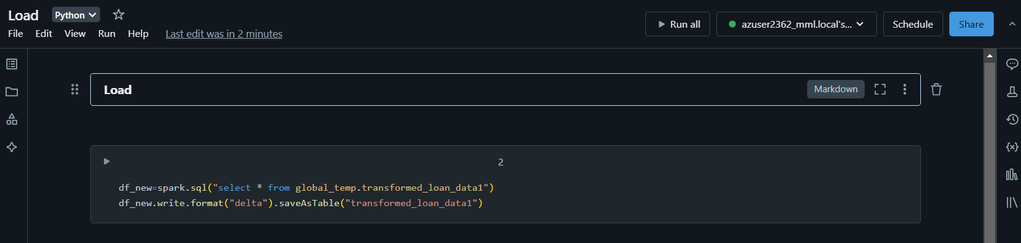

**Go to workflows and select create job**

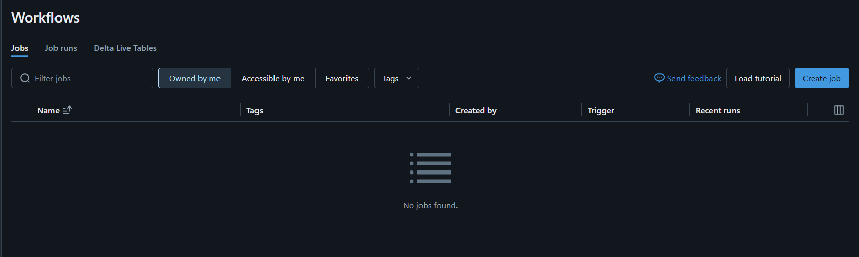

**First create task by adding extract notebook directory**

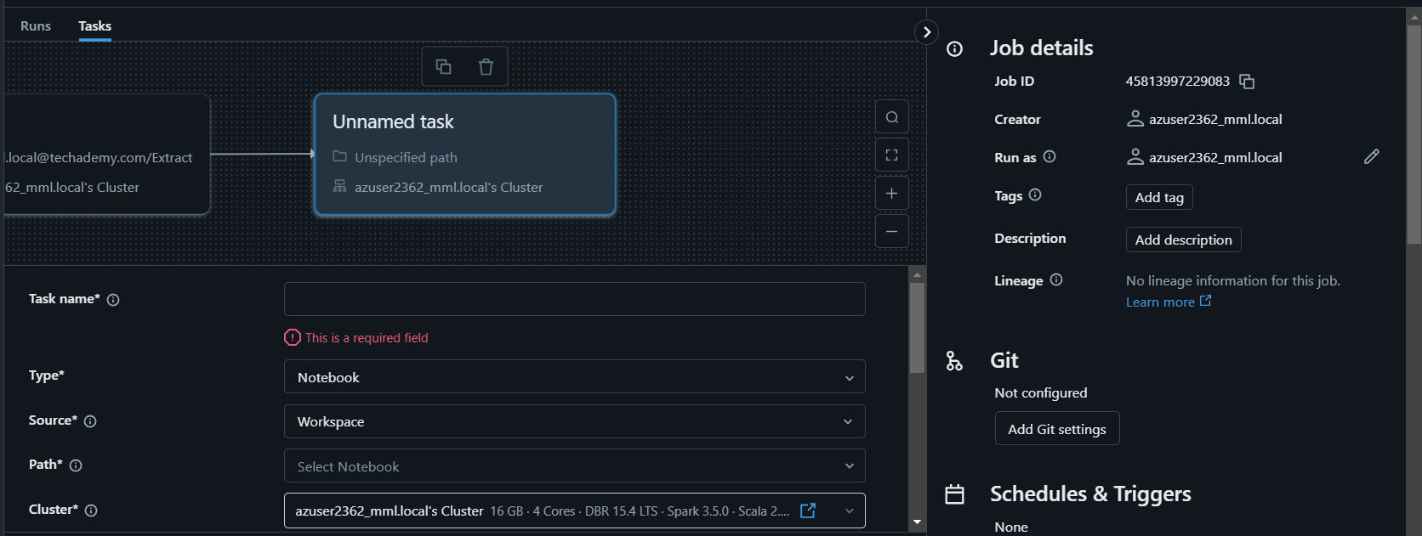

**Click on add task and add transform and load notebooks directory successively.**

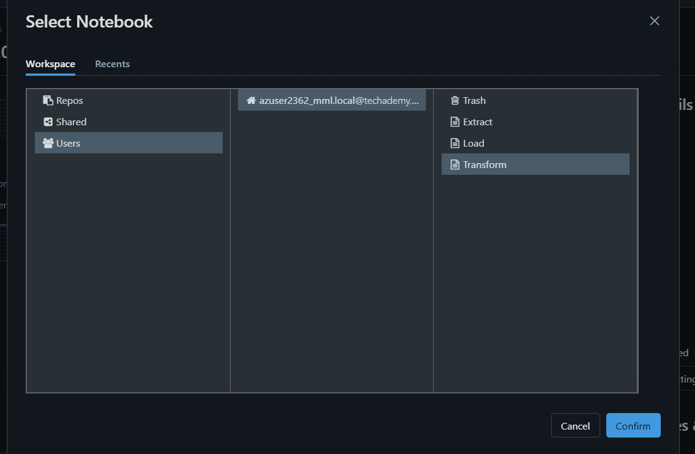

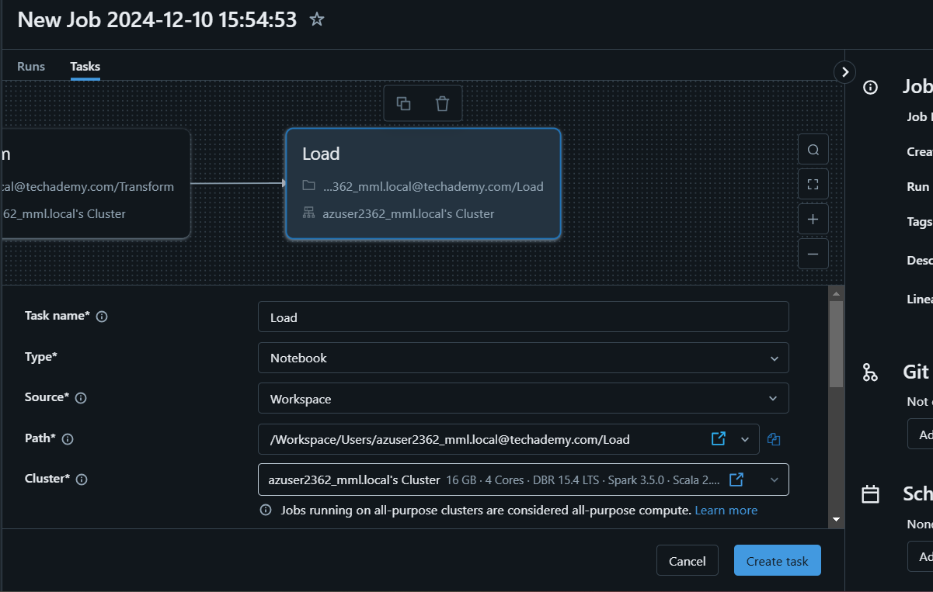

**Click on run now and wait until job run gets completed.**

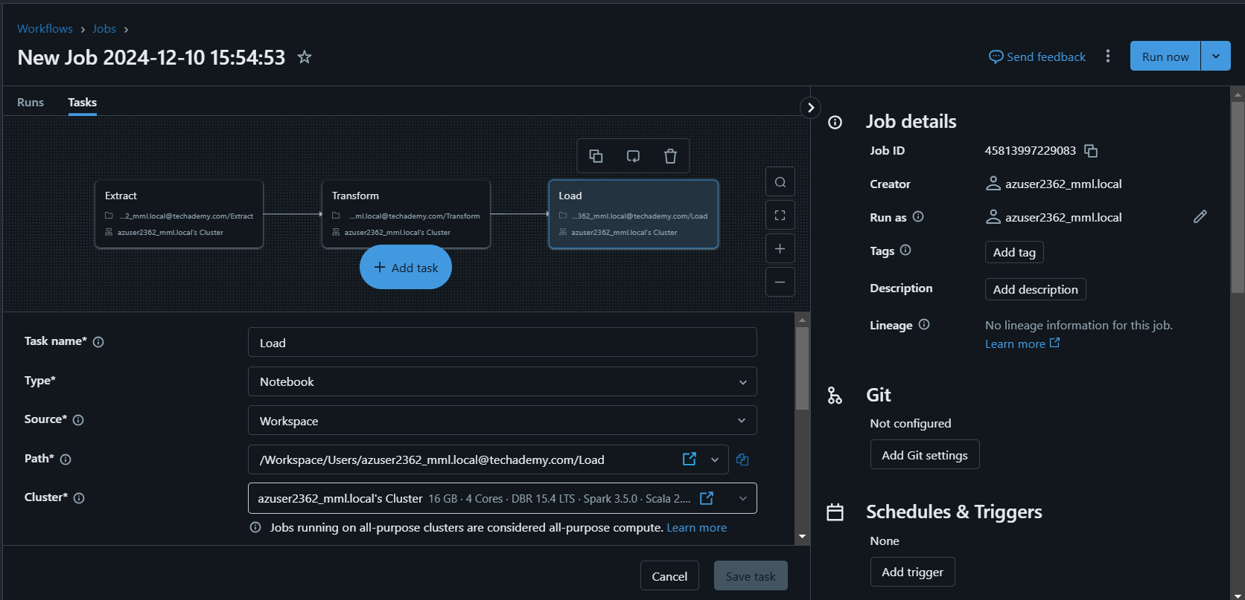



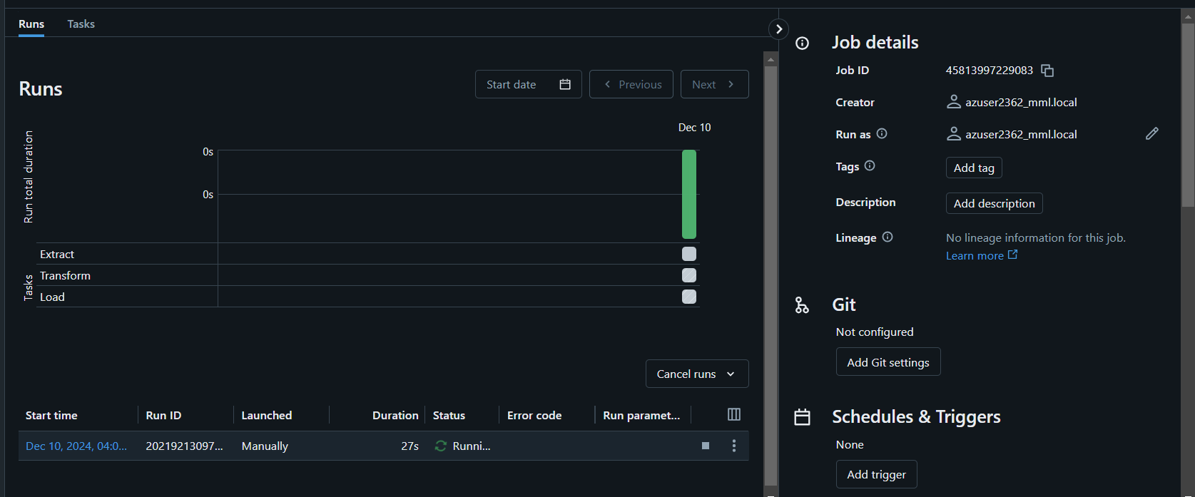

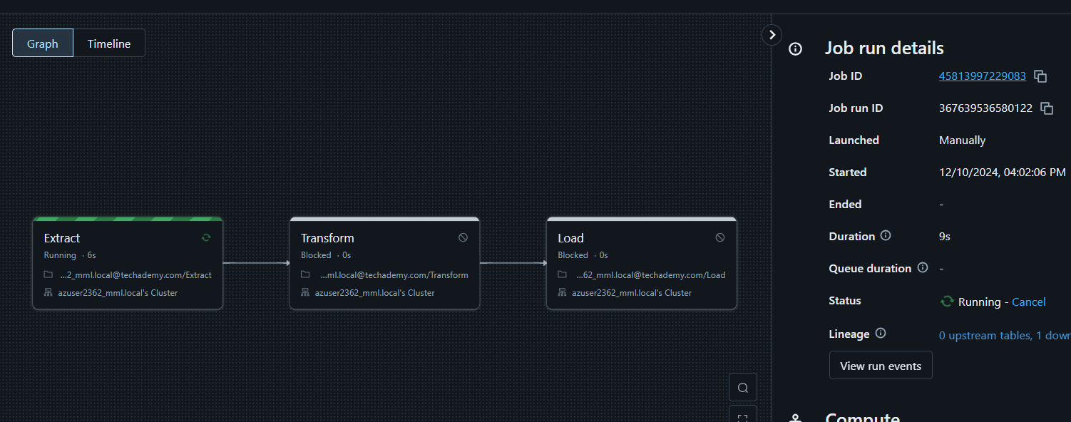

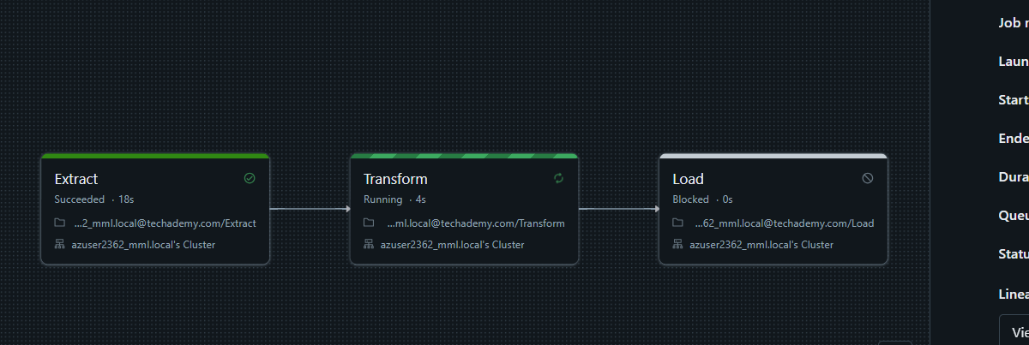

When all the notebooks run the output of the job will be stated as “succeeded”.In case if there are any error in the comands given in notebook the status appear as “Failed”

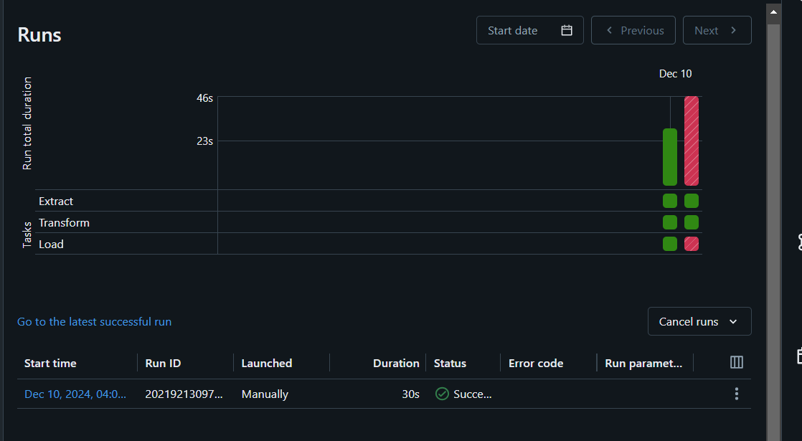

**The loaded data is present in catalog as delta tables**

